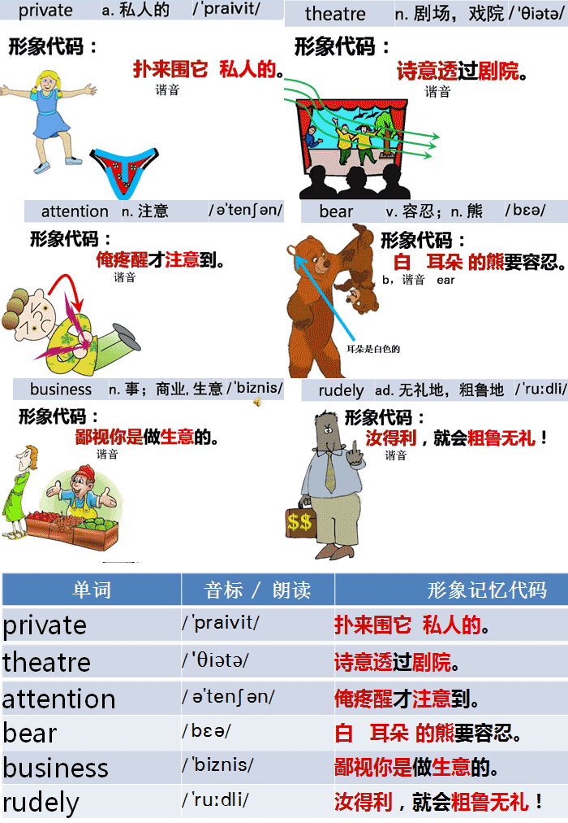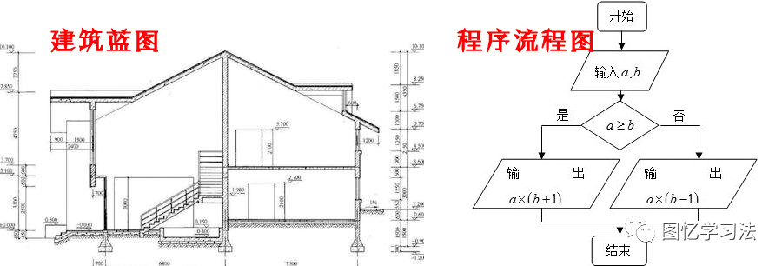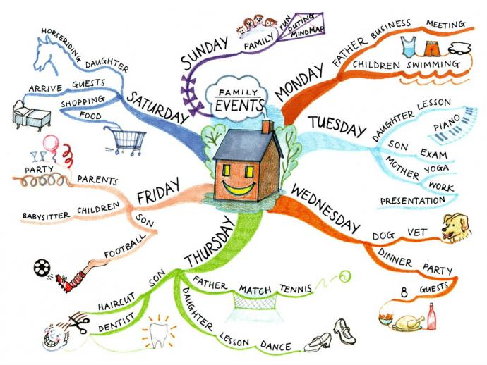讀圖方法：從實心圓點開始，順著曲線念，一直到該曲線終結為止。觀察帶有文字的圖大約三到五遍，即可利用不帶文字的思維導圖進行複述甚至背誦。
圖中有三個關鍵圖符，中間紅色的“我”（頭部有個字母I），我前方（左側）的舞臺，我後面的男女（頭部的M表示男人，W表示女人）。故事就圍繞這三個關鍵圖符展開。仔細觀察這個畫面，大的佈局可能很久都不會忘記；完全背誦了這篇課文，比直接背誦更迅捷，記憶更持久。
圖憶用一張圖凝固了空間場景和時間關係，差異性極大的佈局符合記憶規律，是渡人無數的神來之作。愛因斯坦只是在頭腦中想像它，並宣稱“天才的思維是直觀的”，但圖憶把它畫出來了，使每個中國人都能以天才的方式進行思考和記憶成為可能。
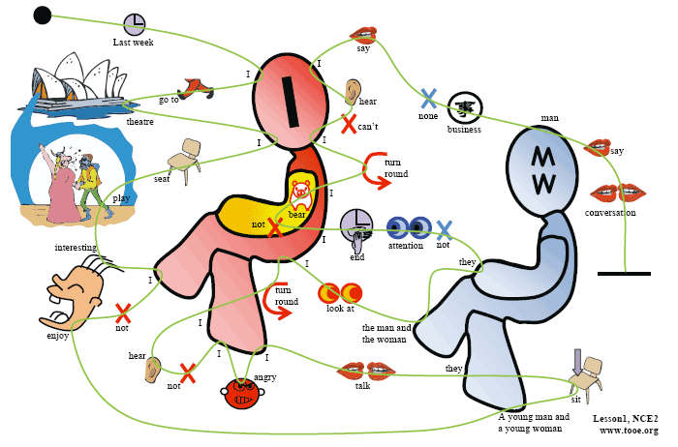Last week I went to the theatre. I had a very good seat.The play was very interesting.I did not enjoy it. A young man and a young woman were sitting behind me. They were talking loudly.I got very angry.I could not hear the actors.I turned round.I looked at the man and the woman angrily.They did not pay any attention. In the end, I could not bear it. I turned round again. ‘I can't hear a word!’I said angrily.
‘It's none of your business,’the young man said rudely.
‘This is a private conversation!’
參考譯文
上星期我去看戲。我的座位很好，戲很有意思，但我卻無法欣賞。一青年男子與一青年女子坐在我的身後，大聲地說著話。我非常生氣，因為我聽不見演員在說什麼。我回過頭去怒視著那一男一女，他們卻毫不理會。最後，我忍不住了，又一次回過頭去，生氣地說：“我一個字也聽不見了！”
“不關你的事，”那男的毫不客氣地說，“這是私人間的談話！
關於圖的分析：先看圖的佈局。我（紅色人形圖示）在中間，左側是舞臺，右側圖示表示那對男女。這樣，課文描繪的空間場景就出來了。再看左上角的小圓黑點，表示課文的開始，小圓黑點發出的那條線表示課文的上下文關係，跟著念就能把課文念出來。
圖憶只用一幅畫面，就表達了課文的空間場景和時間（上下文）關係，使學習者能夠直觀地在畫面上推測、分析課文的內容，並用右腦快速記憶。
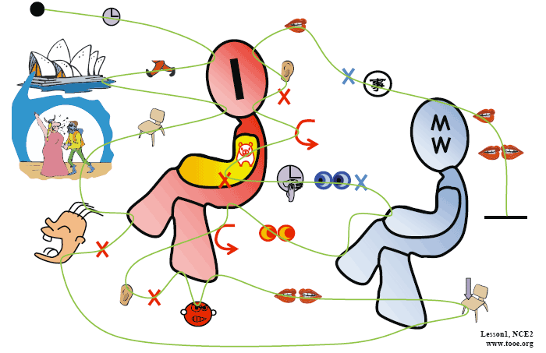

課文原文：
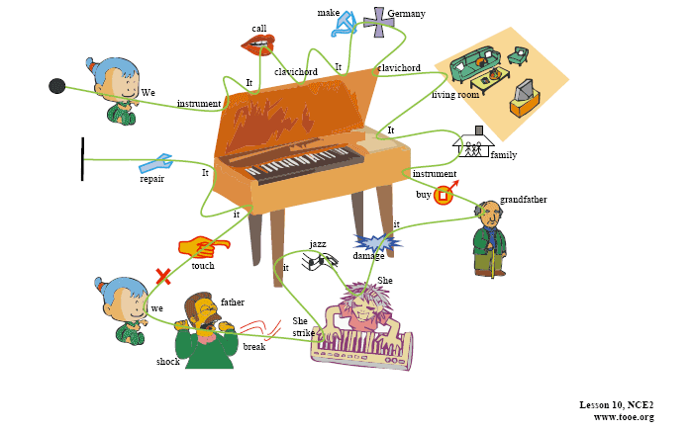We have an old musical instrument. It is called a clavichord. It was made in Germany in 1681. Our clavichord is kept in the living room. It has belonged to our family for a long time. The instrument was bought by my grandfather many years ago. Recently it was damaged by a visitor. She tried to play jazz on it! She struck the keys too hard and two of the strings were broken. My father was shocked. Now we are not allowed to touch it. It is being repaired by a friend of my father's.
參考譯文：我家有件古樂器，被稱作古鋼琴，是1681年德國造的。我們的這架古鋼琴存放在起居室裡。我們家有這件樂器已經很久了， 是我祖父在很多年以前買的。可它最近被一個客人弄壞了，因為她用它來彈奏爵士樂。她在擊琴鍵時用力過猛，損壞了兩根琴弦。我父親大為吃驚，不許我們再動它。父親的一個朋友正在修理這件樂器。
以下為純思維導圖：
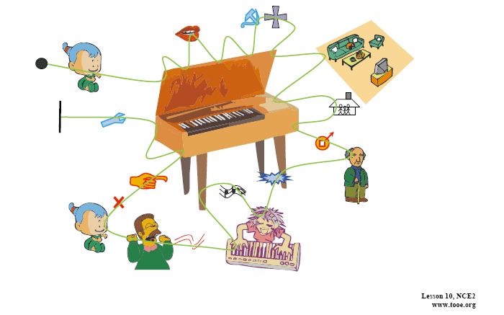
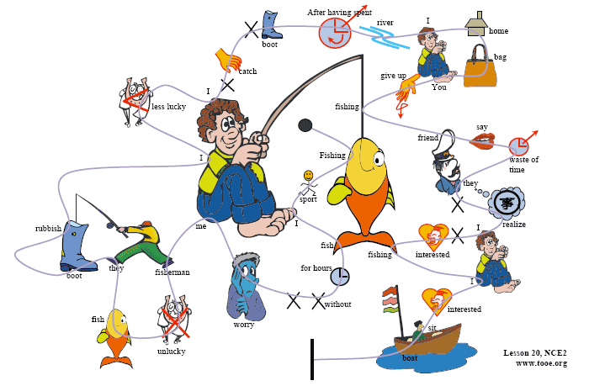Instead of catching fish,they catch old boots and rubbish. I am even less lucky. I never catch anything not even old boots. After having spent whole mornings on the river, I always go home with an empty bag. ‘You must give up fishing' my friends say.‘It's a waste of time.' But they don't realize one important thing. I'm not really interested in fishing. I am only interested in sitting in a boat and doing nothing at all !
參考譯文
釣魚是我特別喜愛的一項運動。我經常一釣數小時卻一無所獲，但我從不為此煩惱。有些垂釣者就是不走運，他們往往魚釣不到，卻釣上來些舊靴子和垃圾。我的運氣甚至還不及他們。我什麼東西也未釣到過 -- 就連舊靴子也沒有。我總是在河上呆上整整一上午，然後空著袋子回家。“你可別再釣魚了！”我的朋友們說，“這是浪費時間。”然而他們沒有認識到重要的一點，我並不是真的對釣魚有興趣，我感興趣的只是獨坐孤舟，無所事事！
以下為純思維導圖：
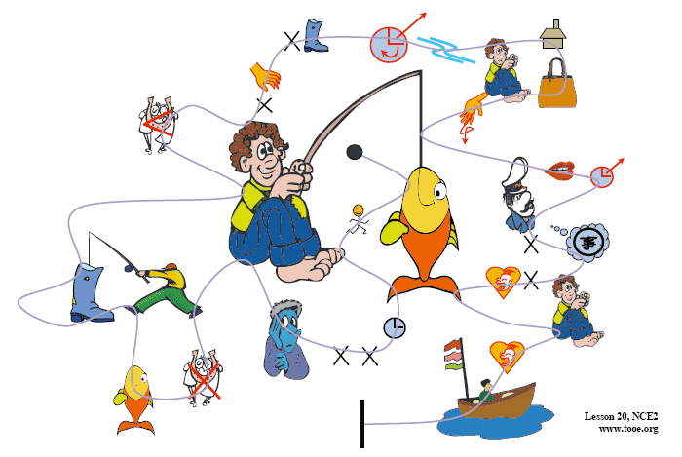課文原文：
The Wayle is a small river that cuts across the park near my home. I like sitting by the Wayle on fine afternoons.It was warm last Sunday, so I went and sat on the river bank as usual. Some children were playing games on the bank and there were some people rowing on the river. 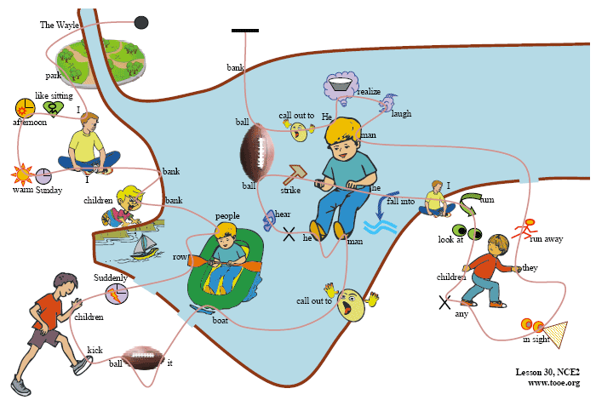Suddenly, one of the children
kicked a ball very hard and it went towards a passing boat. Some people on the bank called out to the man in the boat,but he did not hear them. The ball struck him so hard that he nearly fell into the water. I turned to look at the children,but there weren't any in sight: they had all run away The man laughed when he realized what had happened. He called out to the children and threw the ball back to the bank.
參考譯文
威爾河是橫穿過我家附近公園的一條小河。我喜歡在天氣晴朗的下午到河邊坐坐。上星期日天氣很暖和。於是我和往常一樣，又去河邊坐著。河岸上有些孩子正在玩耍，河面上有些人正在划船。突然，一個孩子狠狠地踢了一腳球，球便向著一隻劃過來的小船飛去。岸上的一些人對著小船上的人高喊，但他沒有聽見。球重重地打在他身上，使他差點兒落入水中。我轉過頭去看那些孩子，但一個也不見，全都跑了！當那個人明白了發生的事情時，笑了起來。他大聲叫著那些孩子，把球扔回到岸上。
以下為純思維導圖：
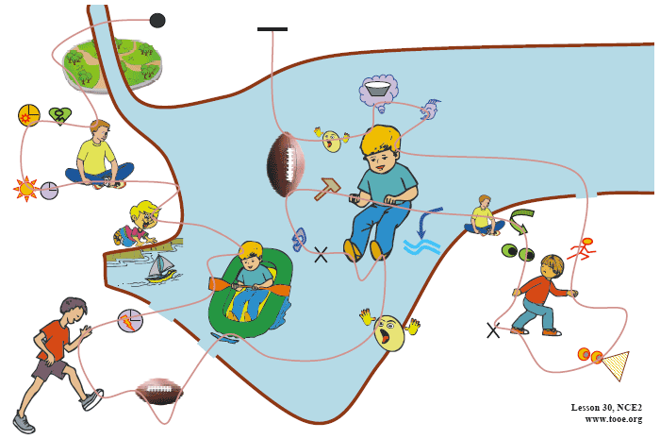課文原文：
The Wayle is a small river that cuts across the park near my home. I like sitting by the Wayle on fine afternoons.It was warm last Sunday, so I went and sat on the river bank as usual. Some children were playing games on the bank and there were some people rowing on the river. Suddenly, one of the children
kicked a ball very hard and it went towards a passing boat. Some people on the bank called out to the man in the boat,but he did not hear them. The ball struck him so hard that he nearly fell into the water. I turned to look at the children,but there weren't any in sight: they had all run away The man laughed when he realized what had happened. He called out to the children and threw the ball back to the bank.
參考譯文
威爾河是橫穿過我家附近公園的一條小河。我喜歡在天氣晴朗的下午到河邊坐坐。上星期日天氣很暖和。於是我和往常一樣，又去河邊坐著。河岸上有些孩子正在玩耍，河面上有些人正在划船。突然，一個孩子狠狠地踢了一腳球，球便向著一隻劃過來的小船飛去。岸上的一些人對著小船上的人高喊，但他沒有聽見。球重重地打在他身上，使他差點兒落入水中。我轉過頭去看那些孩子，但一個也不見，全都跑了！當那個人明白了發生的事情時，笑了起來。他大聲叫著那些孩子，把球扔回到岸上。
以下為純思維導圖：
The Olympic Games will be held in our country in four years' time. As a great many people will be visiting the country, the government will be building new hotels, an immense stadium, and a new Olympic standard swimming pool. 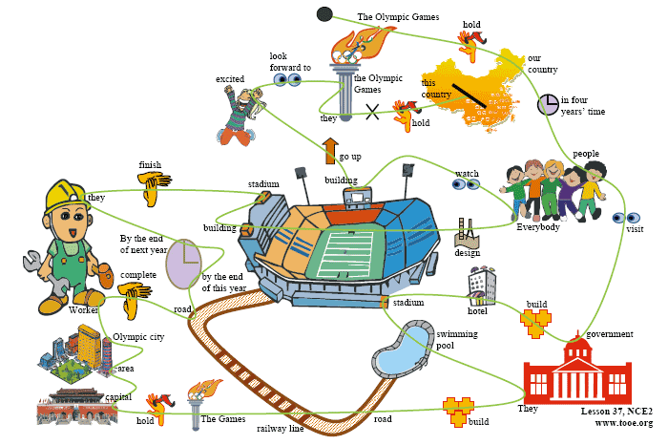They will also be building new roads and a special railway line. The Games will be held just outside the capital and the whole area will be called‘Olympic City’. Workers will have completed the new roads by the end of this year. By the end of next year, they will have finished work on the new stadium. The fantastic modern buildings have been designed by Kurt Gunter. Everybody will be watching anxiously as the new buildings go up. We are all very excited and are looking forward to the Olympic Games because they have never been held before in this country.
課文譯文：
四年以後，奧林匹克運動會將在我們國家舉行。由於將有大批的人到我們國家來，所以政府準備建造一些新的飯店、一個大型體育場和一個新的奧運會標準游泳池。他們還將建築一些新的道路和一條鐵路專線。奧運會就在首都市郊舉辦，整個地區將被稱作“奧林匹克城”。工人們將在今年年底前把新路鋪好。到明年年底，他們將把新體育場建成。這些巨大的現代化建築是由庫爾特●岡特設計的，大家都將急切地注視著新建築的建成。我們都非常激動，盼望著奧運會的到來，因為在這個國家裡還從未舉辦過奧運會。
特別提示：圖憶教程不包含課文英文文字、漢語翻譯和帶漢語關鍵字的思維導圖，只有帶英文關鍵字的思維導圖和純思維導圖。需要與新概念英語教材配合使用。
下面就是純思維導圖，試著看著此圖把課文複述出來：
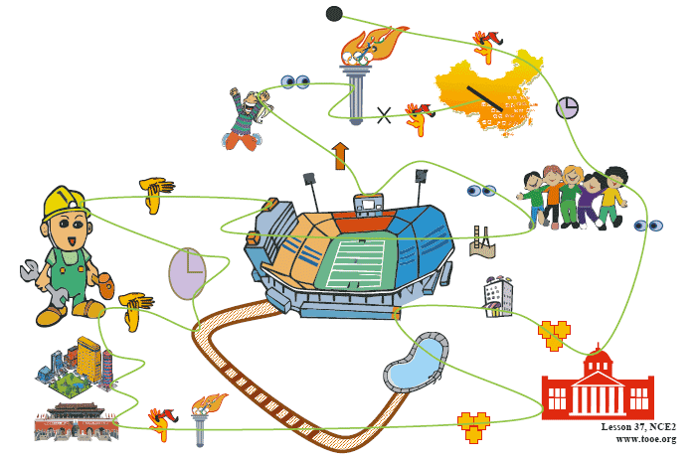課文原文：
Last week at a dinner party, the hostess asked me to sit next to Mrs. Rumbold. Mrs. Rumbold was a large, unsmiling lady in a tight black dress. She did not even look up when I took my seat beside her. Her eyes were fixed on her plate and in a short time, she was busy eating. I tried to make conversation.
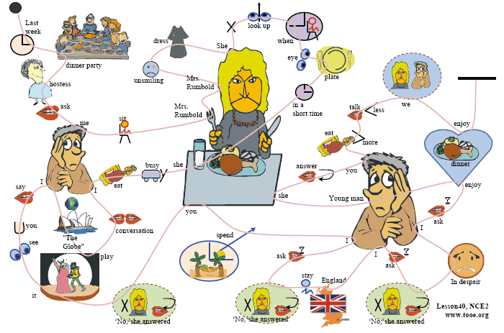‘A new play is coming to“The Globe”soon,' I said.‘Will you be seeing it?’
‘No,’she answered.
‘Will you be spending your holidays abroad this year?’I asked.
‘NO,’she answered.
‘Will you be staying in England?’I asked.
‘No,’she answered.
In despair, I asked her whether she was enjoying her dinner.
‘Young man,’she answered,‘if you ate more and talked less, we would both enjoy our dinner!’
注：本課屬於對話型課文，故其思維導圖較為複雜。
參考譯文
在上星期的一次宴會上，女主人安排我坐在蘭伯爾德夫人的身旁。蘭伯爾德夫人是一位身材高大、表情嚴肅的女人，穿一件緊身的黑衣服。當我在她身旁坐下來的時候，她甚至連頭都沒有抬一下。她的眼睛盯著自己的盤子，不一會兒就忙著吃起來了。我試圖找個話題和她聊聊。
“一出新劇要來‘環球劇場’上演了，”我說，“您去看嗎？”
“不，”她回答。
“您今年去國外度假嗎？”我又問。
“不，”她回答。
“您就呆在英國嗎？”我問。
“不，”她回答。
失望之中我問她飯是否吃得滿意。
“年輕人，”她回答說，“如果你多吃點，少說點，我們兩個都會吃得好的！”
以下為純思維導圖：
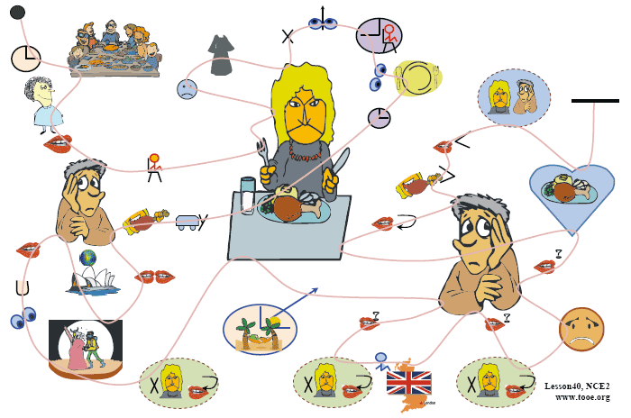課文原文：
I love traveling in the country, but I don't like losing my way. I went on an excursion recently, but my trip took me longer than I expected.
‘I'm going to Woodford Green,’I said to the conductor as I got on the bus,‘but I don't know where it is.'
‘I'll tell you where to get off,’answered the conductor.
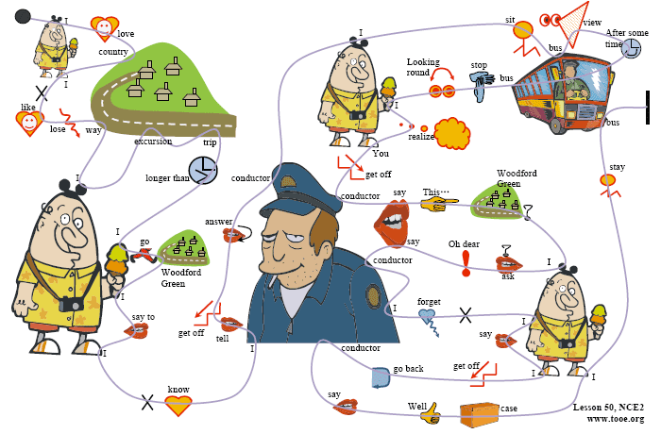I sat in the front of the bus to get a good view of the countryside. After some time, the bus stopped. Looking round, I realized with a shock that I .was the only passenger left on the bus.
‘You'll have to get off here,’the condoctor said. ‘This is as far as we go.’
‘Is this Woodford green?’I asked. .
‘Oh dear,’said the conductor suddenly.‘I forgot to put you off’
‘It doesn't matter,’I said.‘I'll get off here.’
‘We are going back now,’said the conductor.
‘Well,in that case,I prefer to stay on the bus,’I answered.
注：本課屬於對話型課文，故其思維導圖較為複雜。
參考譯文
我喜歡在鄉間旅行，但卻不願意迷路。最近我作了一次短途旅行，但這次旅行所花費的時間比我預計的要長。
“我要去伍德福德草地，”我一上車就對售票員說，“但我不知道它在那兒。”
“我來告訴您在哪兒下車，”售票員回答說。
我坐在汽車的前部，以便飽覽農村風光。過了一些時候，車停了。我環視了一下身旁，驚奇地發現車裡就只剩我一個乘客了。
“您得在這裡下車，”售票員說，“我們的車就到此為止了。”
“這裡是伍德福德草地嗎？”我問道。
“哎呀，”售票員突然說，“我忘了讓您下車了。”
“沒關係，”我說，“我就在這兒下吧。”
“我們現在要返回去，”售票員說。
“好吧，既然如此，我還是留在車上吧。”我回答說。
以下為純思維導圖：
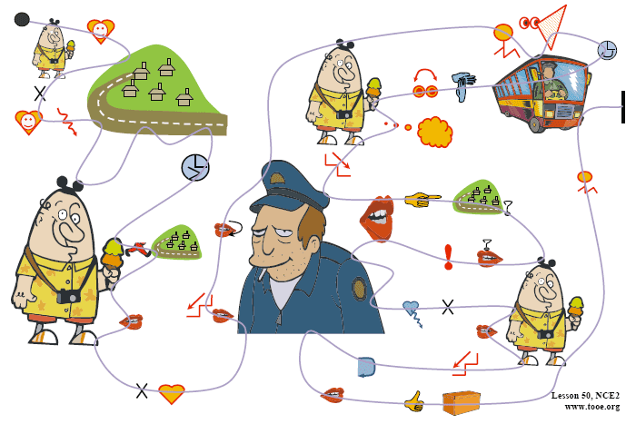課文原文：
At a village fair, I decided to visit a fortune teller called Madam Bellinsky. I went into her tent and she told me to sit down. After I had given her some money,she looked into a crystal ball and said :
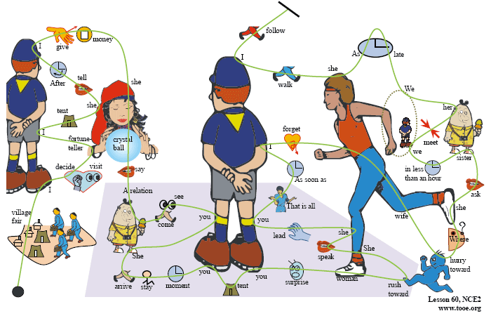‘A relation of yours is coming to see you.She will be arriving this evening and intends to stay for a few days. The moment you leave this tent, you will get a big surprise. A woman you know well will rush towards you. She will speak to you and then she will lead you away from this place. That is all.’As soon as I went outside, I forgot all about Madam Bellinsky because my wife hurried towards me.‘Where have you been hiding?’she asked impatiently.‘Your sister will be here in less than an hour and we must be at the station to meet her. We are late already.’As she walked away, I followed her out of the fair.
參考譯文
在一個鄉村集市上，我決定去拜訪一位稱作別林斯基夫人的算命人。我走進她的帳篷，她叫我坐下。我給了她一些錢後，她便查看著一個水晶球說道：“您的一個親戚就要來看您了。她將於今天傍晚到達，並準備住上幾天。您一走出這個帳篷，就會大吃一驚。一位您很熟悉的女人將向您沖來。她會對您說點什麼，然後帶您離開這個地方。就是這些。”
我一走出帳篷，就把別林斯基夫人給算卦的事忘得一乾二淨了，因為我的妻子正匆匆向我跑來。“你躲到哪兒去了？”她不耐煩地問，“再有不到一個小時你姐姐就要到這兒了，我們得去車站接她。現在就已經晚了。”當她走開時，我也跟著她出了集市。
以下為純思維導圖：
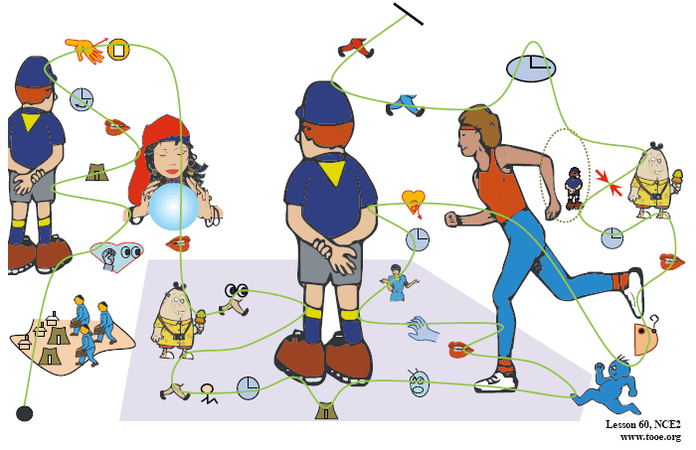

Fishing is my favorite sport. I often fish for hours without catching anything. But this does not worry me. Some fishermen are unlucky. Instead of catching fish,they catch old boots and rubbish. I am even less lucky. I never catch anything not even old boots. After having spent whole mornings on the river, I always go home with an empty bag. ‘You must give up fishing' my friends say.‘It's a waste of time.' But they don't realize one important thing. I'm not really interested in fishing. I am only interested in sitting in a boat and doing nothing at all !
參考譯文
釣魚是我特別喜愛的一項運動。我經常一釣數小時卻一無所獲，但我從不為此煩惱。有些垂釣者就是不走運，他們往往魚釣不到，卻釣上來些舊靴子和垃圾。我的運氣甚至還不及他們。我什麼東西也未釣到過 -- 就連舊靴子也沒有。我總是在河上呆上整整一上午，然後空著袋子回家。“你可別再釣魚了！”我的朋友們說，“這是浪費時間。”然而他們沒有認識到重要的一點，我並不是真的對釣魚有興趣，我感興趣的只是獨坐孤舟，無所事事！The Wayle is a small river that cuts across the park near my home. I like sitting by the Wayle on fine afternoons.It was warm last Sunday, so I went and sat on the river bank as usual. Some children were playing games on the bank and there were some people rowing on the river. Suddenly, one of the children
kicked a ball very hard and it went towards a passing boat. Some people on the bank called out to the man in the boat,but he did not hear them. The ball struck him so hard that he nearly fell into the water. I turned to look at the children,but there weren't any in sight: they had all run away The man laughed when he realized what had happened. He called out to the children and threw the ball back to the bank.
參考譯文
威爾河是橫穿過我家附近公園的一條小河。我喜歡在天氣晴朗的下午到河邊坐坐。上星期日天氣很暖和。於是我和往常一樣，又去河邊坐著。河岸上有些孩子正在玩耍，河面上有些人正在划船。突然，一個孩子狠狠地踢了一腳球，球便向著一隻劃過來的小船飛去。岸上的一些人對著小船上的人高喊，但他沒有聽見。球重重地打在他身上，使他差點兒落入水中。我轉過頭去看那些孩子，但一個也不見，全都跑了！當那個人明白了發生的事情時，笑了起來。他大聲叫著那些孩子，把球扔回到岸上。The Olympic Games will be held in our country in four years' time. As a great many people will be visiting the country, the government will be building new hotels, an immense stadium, and a new Olympic standard swimming pool. They will also be building new roads and a special railway line. The Games will be held just outside the capital and the whole area will be called‘Olympic City’. Workers will have completed the new roads by the end of this year. By the end of next year, they will have finished work on the new stadium. The fantastic modern buildings have been designed by Kurt Gunter. Everybody will be watching anxiously as the new buildings go up. We are all very excited and are looking forward to the Olympic Games because they have never been held before in this country.
課文譯文：
四年以後，奧林匹克運動會將在我們國家舉行。由於將有大批的人到我們國家來，所以政府準備建造一些新的飯店、一個大型體育場和一個新的奧運會標準游泳池。他們還將建築一些新的道路和一條鐵路專線。奧運會就在首都市郊舉辦，整個地區將被稱作“奧林匹克城”。工人們將在今年年底前把新路鋪好。到明年年底，他們將把新體育場建成。這些巨大的現代化建築是由庫爾特●岡特設計的，大家都將急切地注視著新建築的建成。我們都非常激動，盼望著奧運會的到來，因為在這個國家裡還從未舉辦過奧運會。
特別提示：圖憶教程不包含課文英文文字、漢語翻譯和帶漢語關鍵字的思維導圖，只有帶英文關鍵字的思維導圖和純思維導圖。需要與新概念英語教材配合使用。
下面就是純思維導圖，試著看著此圖把課文複述出來：

Last week I went to the theatre. I had a very good seat. The play was very interesting.I did not enjoy it. A young man and a young woman were sitting behind me. They were talking loudly. I got very angry. I could not hear the actors. I turned round. I looked at the man and the woman angrily. They did not pay any attention. In the end, I could not bear it. I turned round again. ‘I can't hear a word!’I said angrily. ‘It's none of your business,’the young man said rudely. ‘This is a private conversation!’
漢語翻譯是：上周我去戲院。我的座位很好。戲很有趣。我卻沒能好好欣賞。一個年輕男人和一個年輕女人坐在我後面，他倆大聲交談。我很氣憤。我無法聽到演員的臺詞。我轉過臉去。我憤怒地看著他們。他倆毫不理睬。最後，我再也忍不住了。我又轉過臉去。“我一句也聽不見！”我憤怒地說。“這您管不著，”年輕男人粗魯地說。“這是私人交談”。
圖示釋義：一個橢圓加上下面的兩隻腿表示人。人頭中的字母I表示“我”，M和W上下相對表示課文中的那對男女，時鐘圖符表示與時間有關的單詞，叉表示“否定”，耳朵表示“聽”，嘴巴表示“說、吵”，兩口相對表示“談話”。

首先從圖中左上角的實心圓點開始念。曲線從實心圓點出發後，遇到了時鐘圖符，表示這裡有一個與時間有關的單詞。對照圖形下麵的課文，得知這個單詞是“last week”。然後，曲線又遇到人形圖符，表示這裡有一個與人有關的單詞。對照課文，這個單詞是“I”。繼續沿曲線走，就會發現“go to”和“theatre”。於是，上述的這幾個單詞就組成了課文的第一個句子：Last week I went to the theatre。

注意需要把圖形中的go to變為正確的時態went to，而且theatre前的冠詞“the”也被省略了。所以，在圖中出現的單詞，被稱為課文的關鍵字。當熟悉這個圖形後，即使不給出關鍵字，也能很快看圖複述整篇課文。沒有關鍵字的思維導圖，稱為“純思維導圖”。

如果您想看沒有解說的“乾淨”的思維導圖，請到圖憶實戰欄目。

關於圖的分析：先看圖的佈局。我（紅色人形圖示）在中間，左側是舞臺，右側圖示表示那對男女。這樣，課文描繪的空間場景就出來了。再看左上角的小圓黑點，表示課文的開始，小圓黑點發出的那條線表示課文的上下文關係，跟著念就能把課文念出來。

圖憶只用一幅畫面，就表達了課文的空間場景和時間（上下文）關係，使學習者能夠直觀地在畫面上推測、分析課文的內容，並用右腦快速記憶。

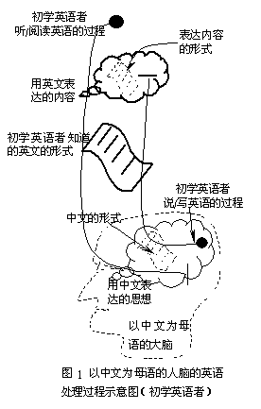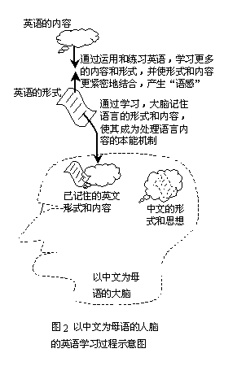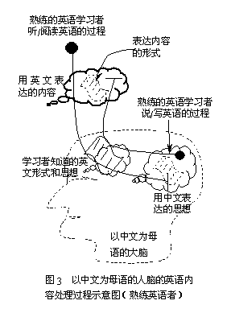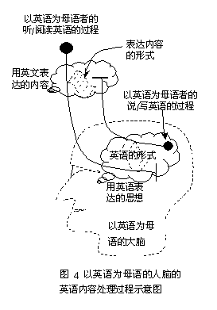

像天才那樣思考
本文來自美國《未來學家》上發表的文章：《像天才那樣思考》，紅色字體簡單地闡釋了圖憶符合“天才思維”模式的依據。

1.天才們以多種角度考慮問題。

天才往往產生於採取了某個其他人沒有採取過的新角度。達·芬奇認為，為了獲得有關某個問題的構成的知識，首先要學會如何從眾多不同的角度重新構建這個問題。他覺得，他看待某個問題的第一種角度太偏向於自己看待事物的通常方式。於是，他就會不停地從一個角度轉向另一個角度，重新構建這個問題。他對問題的理解隨著視角的每一次轉換而逐漸加深，最終他便抓住了問題的實質。事實上，愛因斯坦的相對論就是對不同視角之間的關係的一種解釋。佛洛德的精神分析法旨在找到與傳統方法不符的細節，以便發現一個全新的視角。

闡釋：圖憶指出在缺乏語言環境的條件下，大量背誦課文是最有效的英語學習方式。進一步，用右腦背誦課文是最有效的英語學習方式。

2.天才使自己的思想形象化。

文藝復興時期，人類的創造性得到了迅速發展。這種發展與圖畫和圖表對大量知識的記錄和傳播密切相關。比如，伽俐略用圖表形象地體現出自己的思想，從而在科學上取得了革命性的突破；而他的同時代人使用的還是傳統的數學方法和文字方法。天才們一旦具備了某種起碼的文字能力，似乎就會在視覺和空間能力方面形成某種技能，使他們得以通過不同途徑靈活地展現知識。當愛因斯坦對一個問題做過全面思考以後，他往往會發現，用盡可能多的方式（包括圖表）表述思考物件是必要的。他的思想是非常直觀的；他運用直觀和空間的方式思考，而不是沿著純數位元元元元或文字的推理方式思考。愛因斯坦認為，文字和數位元元元元元元元元元元元在他的思維過程中發揮的作用並不重要。

闡釋：圖憶把課文形象化，學習者跟隨這種“天才的思維方式”進行訓練，久而久之自然形成天才的思維模式。

3.天才善於創造。

天才的一個突出特點就是具有無限的創造力。愛迪生擁有1093項專利，這個記錄迄今無人打破。他給自己和助手確立了提出新想法的定額，以此來保證創造力。他的個人定額是每10天一項小發明，每半年一項大發明。巴赫每星期都要創作一首大合唱，即使在他生病或疲倦時也不例外。莫劄特一生中創作了600多首樂曲。愛因斯坦最著名的作品是關於相對論的論文，但他還發表了另外248篇論文。

闡釋：創造力不是與生俱來的，可以通過學習他人的創造技巧增強自己的創造力。圖憶就像小朋友的積木，是訓練創造力的好工具。

4.天才進行獨創性的組合。

西蒙頓在他撰寫的《科學天才》一書中提出，天才們進行的新穎組合比僅僅稱得上有才的人要多。就像面對著一堆積木的頑皮兒童一樣，天才會在意識和潛意識中不斷地把想法、形象和見解組合並重新組合成不同的形式。愛因斯坦並未發現關於光的能量、品質或速度的概念，而是以一種新穎的方式把這些概念重新組合起來。面對與其他人一樣的世界，他卻能看到不同的東西。構成現代遺傳學基礎的遺傳學法則，也是雷戈·孟德爾在綜合了數學和生物學之後提出來的。

闡釋：圖憶的每幅圖都具有獨創性，具有不同的特徵。

5.天才設法在事物之間建立聯繫。

如果說天才身上突出體現了一種特殊的思想風格，那就是把不同的物件放在一起進行比較的能力。這種在沒有關聯的事物之間建立關聯的能力使他們的得以看到其他人看不到的東西。德國化學家弗裡德里·凱庫勒夢到，一條蛇咬住自己的尾巴，從而憑直覺理解了苯分子的環狀結構。撒母耳·莫爾斯在設法製造出強大的中心越過大洲大洋的電報信號時一籌莫展。一天，他看到拉車的馬匹在驛站被換下來；於是，他由更換馬匹的驛站聯想到了電報信號的中繼站。他終於找到瞭解決辦法：每隔一段距離就把電報信號放大。

闡釋：圖憶把課文的不同段落、不同句子和單詞用線和圖示關聯起來。

6.天才從相對立的角度思考問題。

物理學家和哲學家大衛·博姆認為，天才之所以能夠提出各種不同的見解，是因為他們可以容納相對立的觀點或兩種互不相容的觀點。物理學家尼爾斯·玻爾認為，如果你把兩種對立的思想結合到一起，你的思想就會暫時處於一個不定的狀態，然後會發展到一個新的水準。這種思想的“懸念”，使思考能力之上的智力活躍起來，並創造出一種新的思維方式。對立的思想的糾結纏繞為新觀點的奔湧而出創造了條件。玻爾發現並協原理的能力來源於他把光想像成一種粒子和一種波。愛迪生發明的實用照明裝置就需要在燈泡中把並聯線路與高電阻細金屬絲相結合。因為愛迪生能夠允許兩種互不相容的事物同時存在，他就能夠看到一種他人看不到的關係，從而有所突破。

闡釋：讀者可以根據自己的經驗修改思維導圖，添加或刪減圖示，使圖憶更符合自己的記憶。

7.天才善於比喻。

亞裡斯多德把比喻看作天才的一個標誌。他認為，那些能夠在兩種不同類事物之間發現相似之處並把它們聯繫起來的人具有特殊的才能。如果相異的東西從某種角度看上去確實是相似的，那麼，它們從其他角度看上上去可能也是相似的。亞歷山大·格雷厄姆·貝爾把耳朵的內部構造比作一塊極薄的能夠振動 的鋼片，並由此發明瞭電話。

闡釋：圖憶作者在創作圖憶思維導圖時，大量運用抽象事物形象化的手法，類似於比喻。

8.天才對變化有所準備。

當我們試圖做某一樣事情而失敗的時候，就會去做另一樣事情。這就是在不經意之中有所創造的第一個原則。我們可能會自問，為什麼自己會失敗？這樣問很有道理。但是，使人發揮創造性的偶然因素卻提出了一個不同的問題：我們做了什麼？以一種新穎而意外的方式回答這個問題是能否有所創造的關鍵。 這不是運氣，而是在最高層次上富有創造性的洞察力。亞歷山大·弗萊明不是第一位研究致命的細菌並注意到暴露在空氣中的培養基上會生出黴菌的醫生。一個天分不如他的醫生會忽視這種看似無關的現象，而弗萊明卻認為這“很有趣”，並且想知道這種現象是否有利用的可能。對這種“有趣”現象的觀察最終產生了青黴素。 在思考如何製作碳絲的時候，愛迪生無意中把一根繩子在手指間繞來繞去。當他低頭看手的時候，頓時眼前一亮：把碳像繩子一樣纏繞起來。美國心理學家伯爾休 斯·斯金納強調，科學方法論學者的一個重要原則是：當你發現某樣有趣的事物時，放棄所有其他的事情，專心研究這個事物。大多的人沒能理睬機會的敲門，因為 他們不願不完成事先做好的計畫。天才們不是等待電動機的饋贈，而是去主動地尋求偶然的發現。

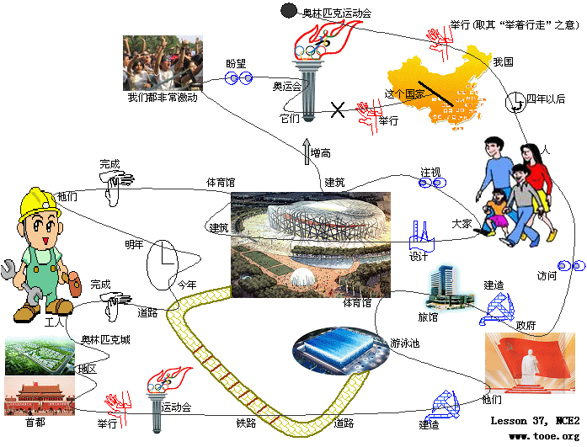課文原文：
Pumas are large, cat like animals which are found in America. When reports came into London Zoo that a wild puma had been spotted forty five miles south of London, they were not taken seriously.However, as the evidence began to accumulate, experts from the Zoo felt obliged to investigate, for the descriptions given by people who claimed to have seen the puma were extraordinarily similar.
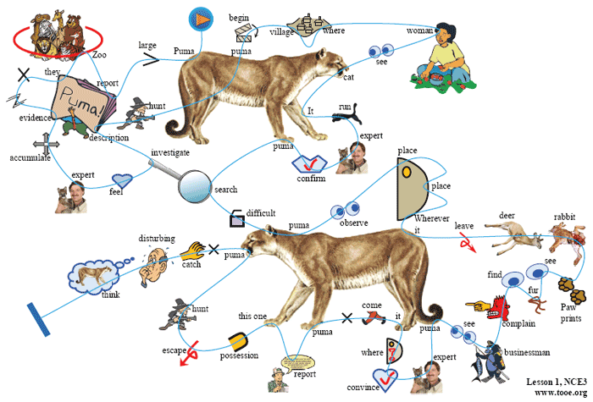The hunt for the puma began in a small village where a woman picking blackberries saw 'a large cat' only five yards away from her. It immediately run away when she saw it, and experts confirmed that a puma will not attack a human being unless it is cornered. The search proved difficult, for the puma was often observed at one place in the morning and at another place twenty miles away in the evening. Wherever it went, it left behind it a trail of dead deer and small animals like rabbits Paw prints were seen in a number of places and puma fur was found clinging to bushes. Several people complained of ‘cat like noises’at night and a business man on a fish trip saw the puma up a tree. The experts were now fully convinced that the animal was a puma, but where had it come from? As no pumas had been reported missing from any zoo in the country. this one must have been in the possession of a private collector and somehow managed to escape. The hunt went on for several weeks, but the puma was not caught. It is disturbing to think that a dangerous wild animal is still at large in the quiet countryside.
參考譯文
美洲獅是一種體形似貓的大動物，產于美洲。當倫敦動物園接到報告說，在倫敦以南45英里處發現一隻美洲獅時，這些報告並沒有受到重視。可是，隨著證據越來越多，動物園的專家們感到有必要進行一番調查，因為凡是聲稱見到過美洲獅的人們所描述的情況竟是出奇地相似。
搜尋美洲獅的工作是從一座小村莊開始的。那裡的一位婦女在採摘黑莓時的看見“一隻大貓”，離她僅5碼遠，她剛看見它，它就立刻逃走了。專家證實，美洲獅非被逼得走投無路，是決不會傷人的。事實上搜尋工作很困難，因為常常是早晨在甲地發現那只美洲獅，晚上卻在20英里外的乙地發現它的蹤跡。無論它走哪兒，一路上總會留下一串死鹿及死兔子之類的小動物，在許多地方看見爪印，灌木叢中發現了粘在上面的美洲獅毛。有人抱怨說夜裡聽見“像貓一樣的叫聲”；一位商人去釣魚，看見那只美洲獅在樹上。專家們如今已經完全肯定那只動物就是美洲獅，但它是從哪兒來的呢？由於全國動物園沒有一家報告丟了美洲獅，因此那只美洲獅一定是某位私人收藏豢養的，不知怎麼設法逃出來了。搜尋工作進行了好幾個星期，但始終未能逮住那只美洲獅。想到在寧靜的鄉村裡有一頭危險的野獸繼續逍遙流竄，真令人擔心。
純思維導圖：
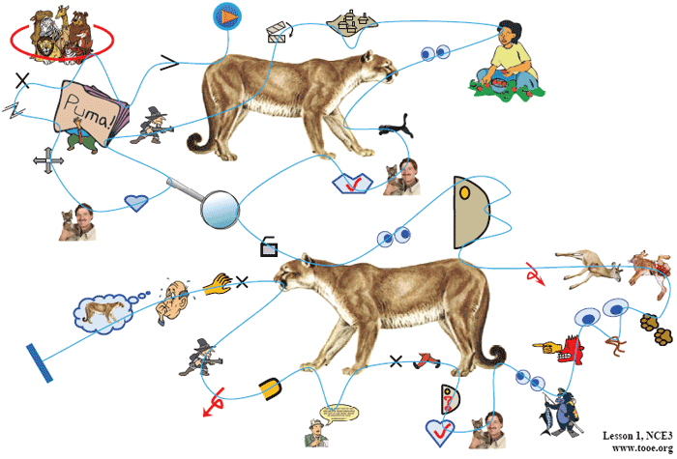課文原文：
The great ship, Titanic, sailed for New York from Southampton on April 10th,1912. She was carrying 1316 passengers and a crew of 891. Even by modern standards, the 46,000 ton Titanic was a colossal ship. At that time, however, she was not only the largest ship that had ever been built, but was regarded as unsinkable, for she had sixteen water tight compartments. Even if two of these were flooded, she would still be able to float. The tragic sinking of this great liner will always be remembered, for shewent down on her first voyage with heavy loss of life.
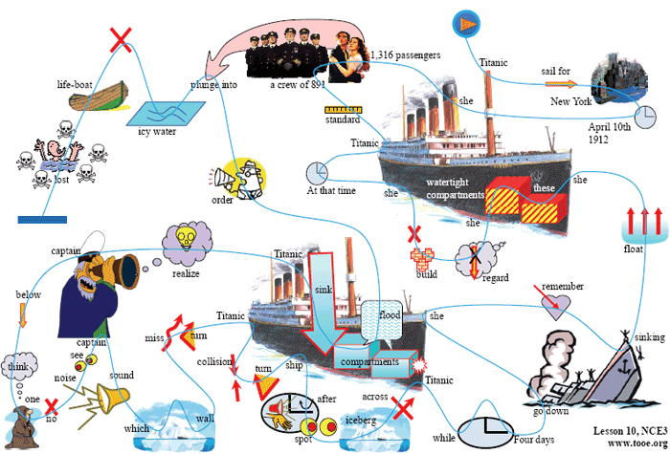Four days after setting out, while the Titanic was sailing across the icy waters of the North Atlantic, a huge iceberg was suddenly spotted by a look out. After the alarm. had been given, the great ship sharply turned sharply to avoid a direct collision. The Titanic turned just in time, narrowly missing the immense wall of ice which rose over 100 feet out of the water beside her. Suddenly, there was a slight trembling sound from below, and the captain went down to see what had happened. The noise had been so faint that no one thought that the ship had been damaged. Below, the captain realized to his horror that the Titanic was sinking rapidly, for five of her sixteen water tight compartments had already been flooded! The order to abandon ship was given and hundreds of people plunged into the icy water. As there were not enough life boats for everybody, 1500 lives were lost.
參考譯文
巨輪“泰坦尼克”號1912年4月10日從南安普敦起錨駛向紐約。船上載有1,316名乘客與891名船員。卻使用現代標準來衡量，45,000 噸的“泰坦尼克”號與算得上一艘巨輪了。當時，這艘輪船不僅是造船史上建造的最大的一艘船，而且也被認為是不會沉沒的。因為船由16個密封艙組成，即使有兩個艙進水，仍可漂浮的水面上。然而，這艘巨輪首航就下沉，造成大批人員死亡。人們將永遠記著這艘巨輪的沉沒慘劇。
“泰坦尼克”起航後的第4天，它正行駛在北大西洋冰冷的海面上。突然，瞭望員發現一座冰山。警報響過不久，巨輪急轉彎，以避免與冰山正面相撞。“泰坦尼克”這個彎拐得及時，緊貼著高出海面100英尺的巨大的冰牆擦過去。突然，從船艙下部傳來一聲微顫音，船長走下船艙去查看究竟。由於這個聲音非常輕，沒人會想到船身已遭損壞。在下面，船長驚恐的地發現“泰坦尼克”號正在急速下沉，16個密封艙已有5個進水。於是，他發出棄船的命令，幾百人跳進了冰冷刺骨的海水裡。由於沒有足夠的救生艇運載所有乘客，結果，1,500 人喪生。
以下為純思維導圖：
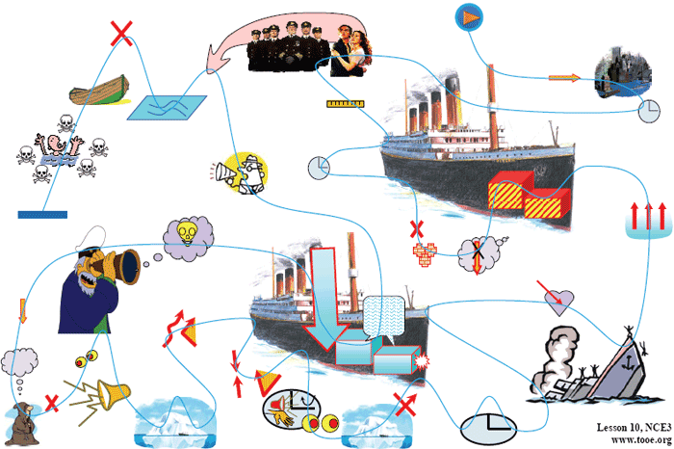课文原文：Some time ago, an interesting discovery was made by archaeologists on the Aegean island of Kea. An American team explored a temple which stands in an ancient city on the promontory of Ayia Irini. The city at one time must have been prosperous, for it enjoyed a high level of civilization. Houses----often three storeys high----were built of stone. They had large rooms with beautifully decorated walls. The city was even equipped with a drainage system, for a great many clay pipes were found beneath the narrow streets.
The temple which the archaeologists explored was used as a place of worship from the fifteenth century B. C. until Roman times. In the most sacred room of the temple, clay fragments of fifteen statues were found. Each of these represented a goddess and had, at one time, been painted. The body of one statue was found among remains dating from the fifteenth century B. C. Its missing head happened to be among remains of the fifth century B. C. This head must have been found in Classical times and carefully preserved. It was very old and precious even then. When the archaeologists reconstructed the fragments, they were amazed to find that the goddess turned out to be a very modern-looking woman. She stood three feet high and her hands rested on her hips. She was wearing a full-length skirt which swept the ground. Despite her great age, she was very graceful indeed, but, so far, the archaeologists have been unable to discover her identity.
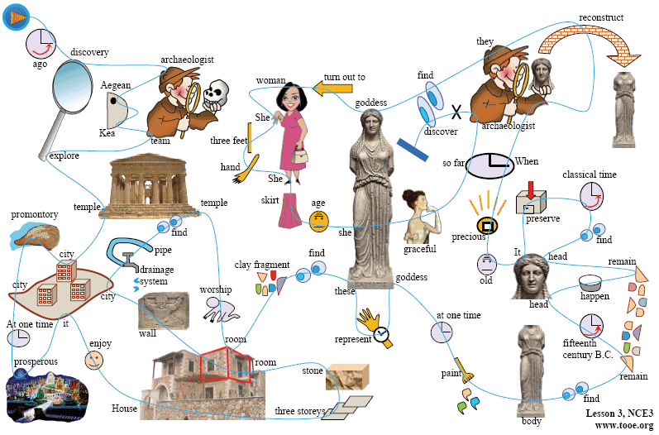
課文原文：
For years villagers believed that Endley farm was haunted. The farm was owned by two brothers, Joe and Bert Cox. They employed a few farm hands, but no one was willing to work there long. Every time a worker gave up his job, he told the same story. Farm labourers said that they always woke up to find the work had been done overnight. Hay had been cut and cow sheds had been cleaned. A farm worker,who stayed up all night, claimed to have seen a figure cutting corn in the moonlight. In time, it became an accepted fact that the Cox brothers employed a conscientious ghost that did most of their work for them.
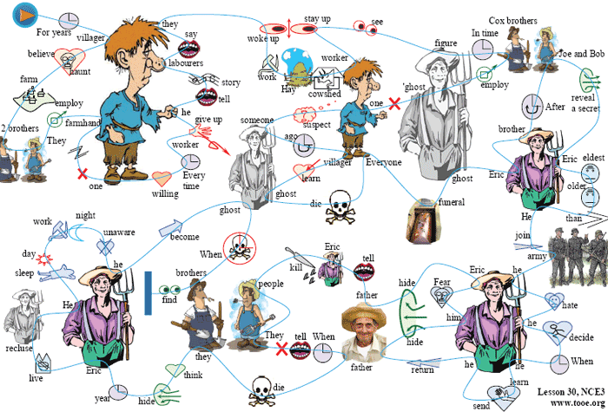No one suspected that there might be someone else on the farm who had never been seen. This was indeed the case. A short time ago, villagers were astonished to learn that the ghost of Endley had died. Everyone went to the funeral, for the 'ghost' was none other than Eric Cox, a third brother who was
supposed to have died as a young man. After the funeral, Joe and Bert revealed a secret which they had kept for over forty years.
Eric had been the eldest son of the family. He had been obliged to join the army during the first World War. As he hated army life he decided to desert his regiment. When he learnt that he would be sent abroad, he returned to the farm and his farther hid him until the end of the war. Fearing the authorities, Eric remained in hiding after the war as well. His father told everybody that Eric
had been killed in action. The only other people who knew the secret were Joe and Bert. They did not even tell their wives. When their father died, they thought it their duty to keep Eric in hiding. All these years, Eric had lived as a recluse.He used to sleep during the day and work at night, quite unaware of the fact that he had become the ghost of Endley. When he died, however, his brothers found it impossible to keep the secret any longer.
參考譯文
多年來，村民們一直認為恩得利農場在鬧鬼。恩得利農場屬於喬.考科斯和鮑勃.考科斯兄弟倆所有。他們雇了幾個農工，但誰也不願意在那兒長期工作下去。每次雇工辭職後都敘述著同樣的故事。雇工們說，常常一早起來發現有人在夜裡把活幹了，乾草已切好，牛棚也打掃乾淨了。有一個徹夜未眠的雇工還聲稱他看見一個人影在月光下收割莊稼。隨著時間的流逝，考科斯兄弟雇了一個盡心盡責的鬼，他們家的活大部分都讓鬼給幹了，這件事成了公認的事實。
誰也沒想到農場竟會有一個從未露面的人。但事實上確有此人。不久之前，村民們驚悉恩得利農場的鬼死了。大家都去參加了葬禮，因為那“鬼”不是別人，正是農場主的兄弟埃裡克.考科斯。人們以為埃裡克年輕時就死了。葬禮之後，喬和鮑勃透露了他們保守了長達50多年的秘密。
埃裡克是這家長子。年齡比他兩個弟弟大很多，第二次世界大戰期間被迫參軍。他討厭軍旅生活，決定逃離所在部隊。當他瞭解自己將被派遣出國時，他逃回農場，父親把他藏了起來，直到戰爭結束。由於害怕當局，埃裡克戰後繼續深藏不露。他的父親告訴大家，埃裡克在戰爭中被打死了。除此之外，只有喬與鮑知道這個秘密。但他倆連自己的妻子都沒告訴。父親死後，他們兄弟倆認為有責任繼續把埃裡克藏起來。這些年來，埃裡克過著隱士生活，白天睡覺，夜裡出來幹活，一點不知道自己已成了恩得利家場的活鬼。他死後，他的弟弟們才覺得無法再保守這個秘密了。
以下為純思維導圖：
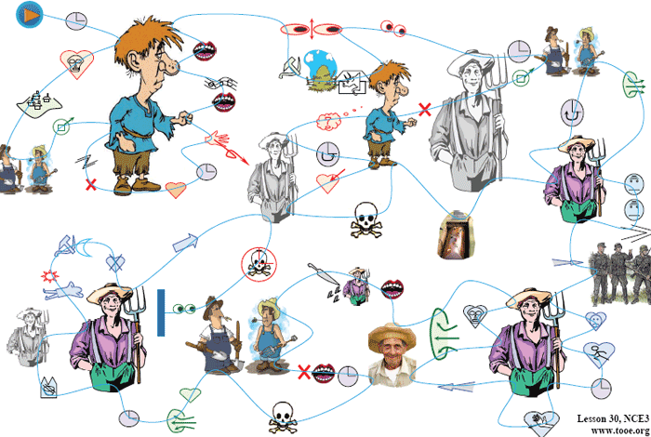課文原文：
It has never been explained why university students seem to enjoy practical jokes more than anyone else. Students specialize in a particular type of practical joke: the hoax. Inviting the firebrigade to put out a non-existent fire is a crude form of deception which no self-respecting student would ever indulge in, Students often create amusing situations which are funny to everyone except the victims.
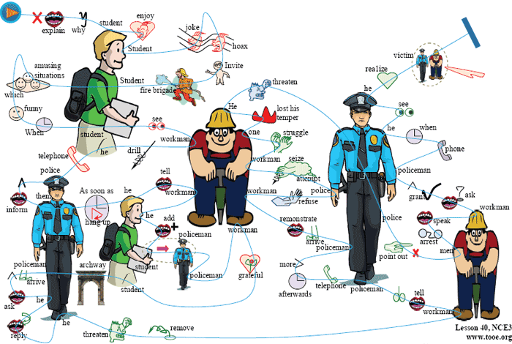When a student recently saw two workmen using a pneumatic drill outside his university, he immediately telephoned the police and informed them that two students dressed up as workmen were
tearing up the road with a pneumatic drill. As soon as he had hung up, he went over to the workmen and told them that if a policeman ordered them to go away, they were not to take him seriously.
He added that a student had dressed up as a policeman and was playing all sorts of silly jokes on people. Both the police and the workmen were grateful to the student for this piece of advance information.
The student hid in an archway nearby where he could watch and hear everything that went on. Sure enough, a policeman arrived on the scene and politely asked the workmen to go away. When he received a very rude reply from one of the workmen, he threatened to remove them by force. The workmen told him to do as he pleased and the policeman telephoned for help. Shortly afterwards, four more policemen arrived and remonstrated with the workmen. As the men refused to stop working, the police attempted to seize the pneumatic drill. The workmen struggled fiercely and one of them lost his temper. He threatened to call the police. At this, the police pointed out ironically that this would hardly be necessary as the men were already under arrest. Pretending to speak seriously, one of the workmen asked if he might make a telephone call before being taken to the station. Permission was granted and a policeman accompanied him to a call-box. Only when he saw that the man was actually telephoning the police did he realize that they had all been the victims of a hoax.
參考譯文
誰也弄不清為什麼大學生好像比任何人都更喜歡惡作劇。大學生擅長一種特殊的惡作劇——戲弄人。請消防隊來撲滅一場根本沒有的大火是一種低級騙局，有自尊心的大學生決不會去做。大學生們常常做的是製造一種可笑的局面，使大家笑上一場，當然受害者是笑不出來的。
最近有個學生看見兩個工人在學校門外用風鑽幹活，馬上打電話報告員警，說有兩個學生裝扮成工人，正在用風鑽破壞路面。掛上電話後，他又馬上來到工人那兒，告訴他們若有個員警來讓他們走開，不要把他當回事，還對工人說，有個學生常裝扮成員警無聊地同別人開玩笑。員警與工人都對那個學生事先通報情況表示感謝。
那個學生躲在附近一拱形的門廊裡，在那兒可以看見、聽到現場發生的一切。果然，員警來了，不禮貌地請工人離開此地；但其中一個工人粗魯地回了幾句。於是員警威脅要強行使他們離開。工人說，悉聽尊便。員警去打電話叫人。一會兒工夫，又來了4個員警，規勸工人離開。由於工人拒絕停下手中的活，員警想奪風鑽。兩個工人奮力抗爭，其中一個發了火，威脅說要去叫員警。員警聽後譏諷地說，這大可不必，因為他倆已被逮捕了。其中一個工人裝模作樣地問道，在被帶往警察局之前，是否可以打一個電話。員警同意了，陪他來到一個投幣地電話前，當他看到那個工人真的是給員警掛電話，才恍然大悟，原來他們都成一場騙局的受害者。
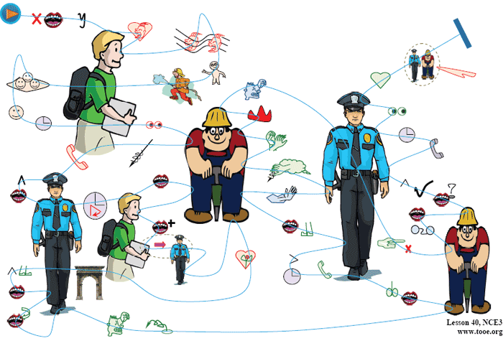
課文原文：
The New Year is a time for resolutions.Mentally, at least, most of us could compile formidable lists of ' do's' and' don'ts '.The same old favourites recur year in year out with monotonous regularity. We resolve to get up earlier each morning,eat less, find more time to play with the children, do a thousand and one jobs about the house, be nice to people we don't like, drive carefully, and take the dog for a walk every day. Past experience has taught us that certain accomplishments are beyond attainment. If we remain inveterate smokers, it is only because we have so often experienced the frustration that results from failure. Most of us fail in our efforts at self improvement because our schemes are too ambitious and we never have time to carry them out. We also make the fundamental error of announcing our resolutions to everybody so that we look even more foolish when we slip back into our bad old ways. Aware of these pitfalls, this year I attempted to keep my resolutions to myself. I limited myself to two modest ambitions: to do physical exercises every morning and to read more of an evening. An all night party on New Year's Eve,provided me with a good excuse for not carrying out either of these new resolutions on the first day of the year,but on the second, I applied myself assiduously to the task.
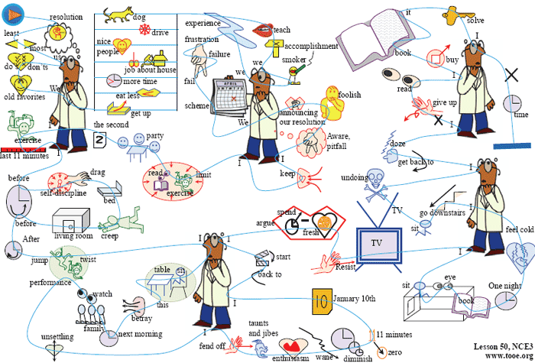The daily exercises lasted only eleven minutes and I proposed to do them early in the morning before anyone had got up. The selfdiscipline required to drag myself out of bed eleven minutes earlier than usual was considerable. Nevertheless, I managed to creep down into the living room for two days before anyone found me out. After jumping about on the carpet and twisting the human frame into uncomfortable positions, I sat down at the breakfast table in an exhausted condition. It was this that betrayed me. The next morning the whole family trooped in to watch the performance. That was really unsettling but I fended off the taunts and jibes of the family good humouredly and soon everybody got used to the idea. However, my enthusiasm waned. The time I spent at exercises gradually diminished. Little by little the eleven minutes fell to zero. By January 10th, I was back to where I had started from. I argued that if I spent less time exhausting myself at exercises in the morning I would keep my mind fresh for reading when I got home from work. Resisting the hypnotizing effect of television, I sat in my room for a few evenings with my eyes glued to a book, one night, however, feeling cold and lonely, I went downstairs and sat in front of the television pretending to read. That proved to be my undoing, for I soon got back to my old bad habit of dozing off in front of the screen. I still haven't given up my resolution to do more reading. In fact, I have just bought a book entitled 'How to Read a Thousand Words a Minute'. Perhaps it will solve my problem, but I just haven't had time to read it!
參考譯文
新年是下決心的時候，至少在大多數人的心裡會編排出一份“應做什麼”和“不應做什麼”的令人生畏的單子。相同的決心以單調的規律年復一年地出現。我們決心每天早晨起得早些；吃得少些；多花點時間與孩子們一起做遊戲；做大量的家務；對不喜歡的人友善一些；小心駕車；每天都要帶著狗散步；等等。以往的經驗告訴我們有些事是辦不到的。如果我們煙癮大，戒不掉，那是因為屢戒屢敗，失去信心。我們大多數人想自我完善卻遭到失敗，這是因為我們的規劃過於宏大，而又根本沒有時間去實施。我們還犯有一個根本性的錯誤，即把我們的決心向大家宣佈。這樣一旦滑回到那些老習慣上去，我們在別人的眼裡會顯得更加難堪。我深知這些問題，於是，今年我對自己的計畫要嚴加保密，只給自己定下兩項適中的任務；每天早上鍛煉身體，每天晚上多看點書。新年除夕舉辦的一次通宵晚會，使我理直氣壯地在新年頭一天免去了這兩項任務。不過，新年第二天，我全力以赴地照著去做了。
早鍛煉一共只有11分鐘，我打算在別人起床之前進行。這就要求我比平時早11分鐘把自己從床上拽起來，這種自我約束是很艱苦的。不過開頭兩天我還是成功地躡手躡腳地來到樓下起居室，被誰也沒發現。我在地毯上跳來蹦過去，扭曲身子，擺出各種姿勢，弄得渾身不舒服，然後坐到桌邊吃早飯，一副筋疲力盡的樣子。正是這副模樣洩露了我的秘密。第二天早晨全家人結隊來到起居室看我表演。這真叫人不好意思，但我心平氣和地頂住全家人的嘲笑和奚落。不久，大家對我習以為常了，而這時我的熱情卻減退了。我花在鍛煉上的時間逐漸減少，慢慢地從11分鐘減到了零。到了1月10日，我恢復了原來的作息時間。我辯解說，早晨少耗費精力鍛煉，晚上下班回家看書時頭腦更清醒些。有幾天晚上，我極力擺脫了電視的誘惑，坐在自己的房間裡，兩眼盯在書上。可是，有一天夜裡，我感到又冷又孤單，便來到樓下坐在電視機前假裝看書。這下我可完了，因為不一會兒，我就恢復了以前的壞習慣，在螢幕前打起瞌睡來。但我還沒有放棄多看些書的決心。事實上，我剛買來一本叫《一分鐘讀一千字的訣竅》的書。也許這本書能解決我的問題，但我一直還沒時間去看這本書！
以下為純思維導圖：
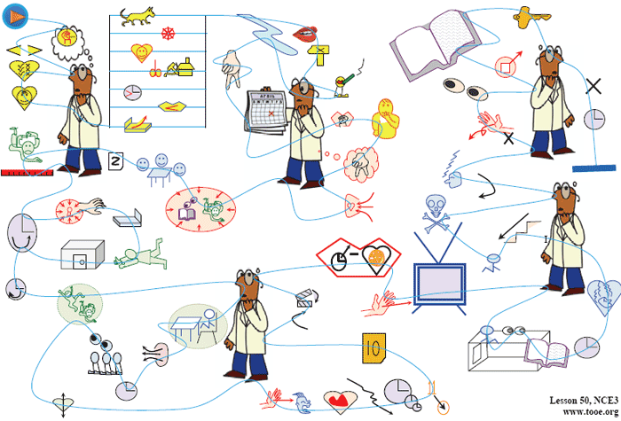
課文原文：
Punctuality is a necessary habit in all public affairs in civilized society. Without it, nothing could ever be brought to a conclusion; everything would be in state of chaos. Only in a sparsely-populated rural community is it possible to disregard it. In ordinary living, there can be some tolerance of unpunctuality. The intellectual, who is working on some abstruse problem, has everything coordinated and organized for the matter in hand. He is therefore forgiven if late for a dinner party. But people are often reproached for unpunctuality when their only fault is cutting things fine. It is hard for energetic, quick-minded people to waste time, so they are often tempted to finish a job before setting out to keep an appointment. If no accidents occur on the way, like punctured tires, diversions of traffic, sudden descent of fog, they will be on time. They are often more industrious, useful citizens than those who are never late. The over-punctual can be as much a trial to others as the unpunctual. The guest who arrives half an hour too soon is the greatest nuisance. Some friends of my family had this irritating habit. The only thing to do was ask them to come half an hour later than the other guests. Then they arrived just when we wanted them.
If you are citing a train, it is always better to be comfortably early than even a fraction of a minted too late. Although being early may mean wasting a little time, th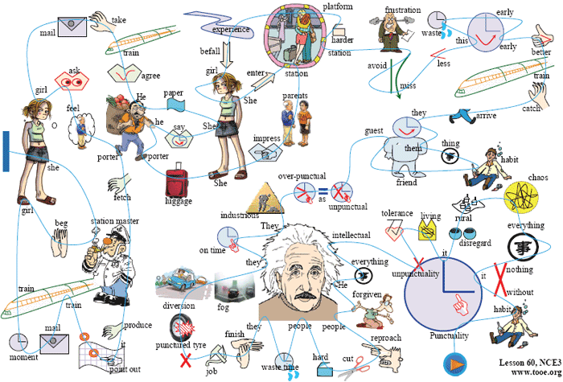is will be less than if you miss the train and have to wait an hour or more for the next one; and you avoid the frustration of arriving at the very moment when the train is drawing out of the station and being unable to get on it. An even harder situation is to be on the platform in good time for a train and still to see it go off without you. Such an experience befell a certain young girl the first time she was traveling alone.
She entered the station twenty minutes before the train was due, since her parents had impressed upon her that it would be unforgivable to miss it and cause the friends with whom she was going to stay to make two journeys to meet her. She gave her luggage to a porter and showed him her ticket. To her horror he said that she was two hours too soon. She felt inhere handbag for the piece of paper on which her father had written down al the details of the journey and gave it to the porter. He agreed that a train did come into the station at the time on the paper and that it did stop, but only to take on mail, not passengers. The girl asked to see a timetable, feeling sure that her father could not have made such a mistake. The porter went to fetch one and arrive back with the station master, who produced it with a flourish and pointed out a microscopic 'o' beside the time of the arrival of the train at his station; this little 'o' indicated that the train only stopped for mail. Just as that moment the train came into the station. The girl, tears streaming down her face, begged to be allowed to slip into the guard's van. But the station master was adamant: rules could not be broken and she had to watch that train disappear towards her destination while she was left behind.
參考譯文
準時是文明社會中進行一切社交活動時必須養成的習慣。不準時將一事無成，事事都會陷入混亂不堪的境地。只有在人口稀少的農村，才可以忽視準時的習慣。在日常生活中人們可以容忍一定程度的不準時。一個專心鑽研某個複雜問題的知識份子，為了搞好手頭的研究，要把一切都協調一致，組織周密。因此，他要是赴宴遲到了會得到諒解。但有些人不準時常常因為掐鐘點所致，他們常常受到責備，精力充沛、頭腦敏捷的人極不願意浪費時間，因此他們常想做完一件事後再去赴約。要是路上沒有發生如爆胎、改道、突然起霧等意外事故，他們決不會遲到。他們與那些從不遲到的人相比，常常是更勤奮有用的公民。早到的人同遲到的人一樣令人討厭。客人提前半小時到達是令人討厭的。我家有幾個朋友就有這有令人惱火的習慣。唯一的辦法就是請他們比別的客人晚來半小時。這樣，他們可以恰好在我們要求的時間到達。
如果趕火車，早到總比晚到好，哪怕早到一會兒也好。雖然早到可能意味著浪費一點時間，但這比誤了火車等上一個多小時坐下班車浪費的時間要少，而且可以避免那種正好在火車駛出站時趕到車站，因上不去車而感到的沮喪。更難堪的情況是雖然及時趕到月臺上，卻眼睜睜地看著那趟火車啟動，把你拋下。一個小姑娘第一次單獨出門就碰到了這種情況。
在火車進站20分鐘前她就進了車站。因為她的父母再三跟她說，如果誤了這趟車，她的東道主朋友就得接她兩趟，這是不應該的。她把行李交給搬運工並給他看了車票。搬運工說她早到了兩個小時，她聽後大吃一驚。她從錢包裡摸出一張紙條，那上面有她父親對這次旅行詳細說明，她把這張紙條交給了搬運工。搬運工說，正如紙條所說，確有一趟火車在那個時刻到站，但它只停站裝郵件，不載旅客。姑娘要求看到時刻表，因為她相信父親不能把這麼大的事弄錯。搬運工跑回去取時刻表，同時請來了站長。站長拿著時刻表一揮手，指著那趟列車到站時刻旁邊一個很小的圓圈標記。這個標記表示列車是為裝郵件而停車。正在這時，火車進站了。女孩淚流滿面，央求讓她不聲不響地到押車員車廂裡去算了。但站長態度堅決，規章制度不能破壞，姑娘只得眼看那趟火車消逝在她要去的方向而撇下了她。
純思維導圖：
